Lab Quiz for PHY324

Q1: What experiment are you doing?

Charge to Mass Ratio

Q2: Summarize the physics elements in this experiment.

- Particles experiencing forces in magnetic fields
- Centripetal acceleration of particles in magnetic fields

Q3: Describe one major goal of the lab.

Finding the ratio of the electron charge to the mass of a particle using the value of the “extra” electric field.

Q4: What do you measure directly in pursuit of the major goal described above?

The main thing we measure is the external electric field from the earth and building and other instruments/devices in the laboratory.

Q5: Outline how you get the answer to Q3 from the data collected as described in Q4. If you will graph data to achieve the goal in Q3 then explain what you will graph, what the trend-line will look like, and how it achieves the goal in Q3. Include any equations you will use to turn the data described in Q4 into the answer described in Q3.

We first need to find the extra electric field using the equation below:

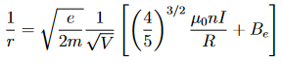

Once we find that, we can find the total axial magnetic field from the equation:

Where Bc is the magnetic field in the coil. Once we have this, we can finally find e/m from the equation:

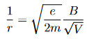

Q6: Your TA asked you a/some question(s) about the equipment. Write the question(s) and answer(s) here.

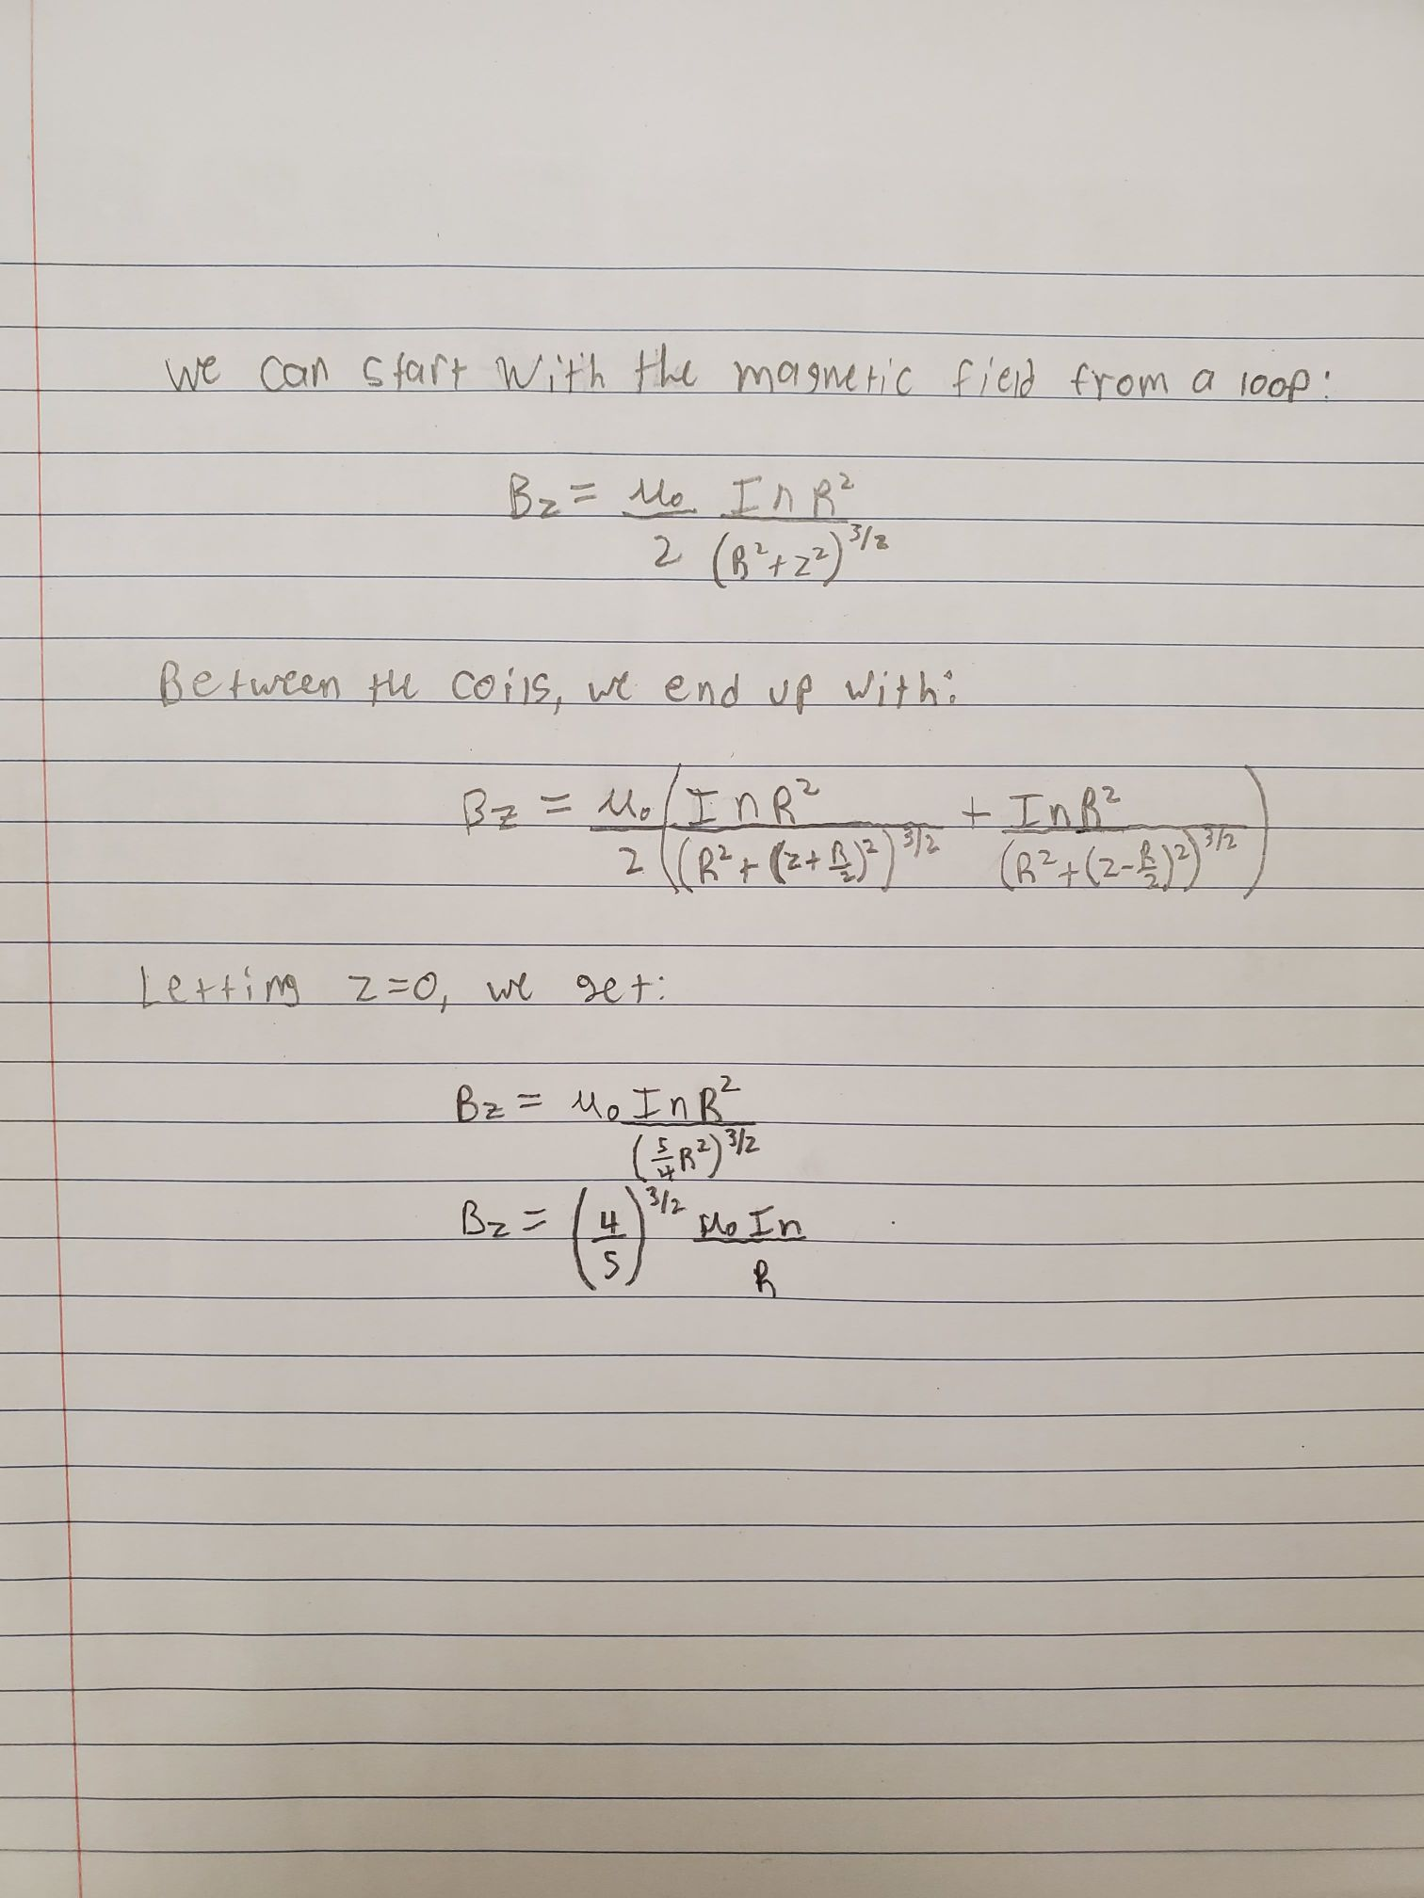
- Derive the magnetic field of the Helmholtz coil

- Which equation in the lab report can be graphed such that it gives Bc and the slope is e/m?

Equation 7

